**TRANSLATION**

#include<stdio.h> #include<conio.h> #include<graphics.h> void main() { int gd=DETECT,gm,x,y,x1,y1,x2,y2,x3,y3,tx,ty; initgraph(&gd,&gm,"c://tc//bgi"); printf("Enter x,y,x1,y1="); scanf("%d%d%d%d",&x,&y,&x1,&y1); bar3d(x,y,x1,y1,40,1); printf("\n enter translation distance="); scanf("%d%d",&tx,&ty); x2=x+tx; x3=x1+tx; y2=y+ty; y3=y1+ty; bar3d(x2,y2,x3,y3,40,1); getch(); closegraph(); }

**OUTPUT**

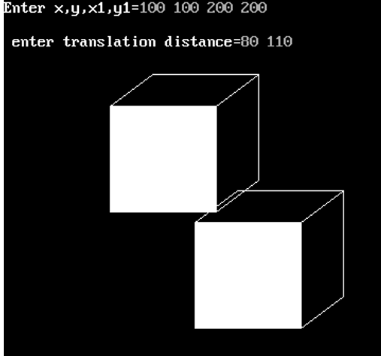

**SCALING**

#include<stdio.h> #include<conio.h> #include<graphics.h> void main() { int gd=DETECT,gm,x,y,x1,y1,x2,y2,x3,y3,sx,sy; initgraph(&gd,&gm,"c://tc//bgi"); printf("Enter x,y,x1,y1="); scanf("%d%d%d%d",&x,&y,&x1,&y1); bar3d(x,y,x1,y1,40,1); printf("\n enter scaling distance="); scanf("%d%d",&sx,&sy); x2=x*sx; x3=x1*sx; y2=y*sy; y3=y1*sy; bar3d(x2,y2,x3,y3,40,1); getch(); closegraph(); }

**OUTPUT**

